**CDAC Mumbai PG-DAC August 24**

**Assignment No- 4**

1. Write a program that demonstrates widening conversion from int to double and prints the result.

package org.example.ques1;

public class program {

public static void main(String[] args) {

int d = 20;

double convertednum= d;

System.***out***.println("the original number:" +d );

System.***out***.println("the converted number:" +convertednum );

}

}

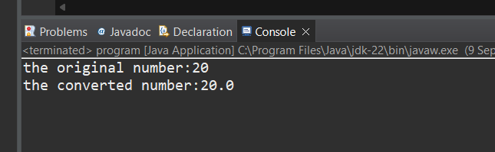

1. Create a program that demonstrates narrowing conversion from double to int and prints the result.

package org.example.ques2;

public class program {

public static void main(String[] args) {

double d = 20;

int i =(int)d;

System.***out***.println("original double value is:" +d );

System.***out***.println("narrowed value is:" +i );

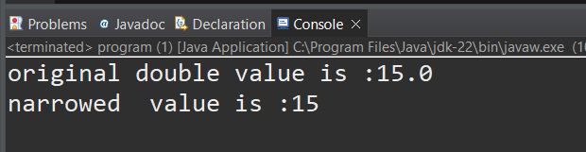

1. Write a program that performs arithmetic operations involving different data types (int, double, float) and observes how Java handles widening conversions automatically.

package org.example.ques3;

public class program {

public static void main(String[] args) {

int i=2;

float j = 3.33f;

double d = 20;

float result1= i+j;

System.***out***.println("result of float:" +result1);

double result2 = j+d;

System.***out***.println("result of double:" +result2);

double result3 = i+d;

System.***out***.println("result of double:" +result3);

double result4 = i*d;

System.***out***.println("result of double:" +result4);

}

}

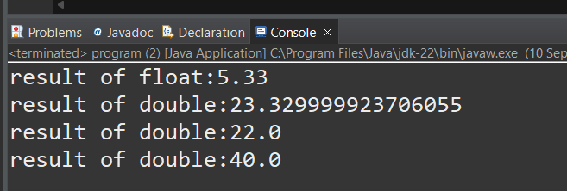

1. Write a Program that demonstrates widening conversion from int to (double,float, boolean, string) and prints the result.

package org.example.ques4;

public class program {

public static void main(String[] args) {

int num = 45;//original

//widening conversion from int to double

double doubleValue = num;

//widening conversion from int to float

float floatValue = num;

//widening conversion from int to boolean

boolean booleanValue =(num != 0);

//convert int to string

String stringValue = String.*valueOf*(num);

System.***out***.println("original int value " + num);

System.***out***.println("widened to double " + doubleValue);

System.***out***.println("widened to float " + floatValue);

System.***out***.println("convert to boolean " + booleanValue);

System.***out***.println("converted to String " + stringValue);

}

}

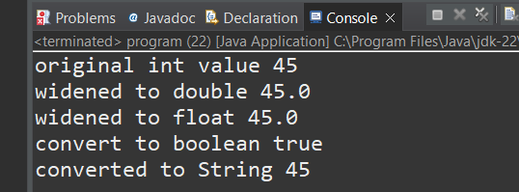

**Interview Questions**

**Note: Write down this interview question on your notebook ,Take a screenshort & Paste that SS in the word document & upload on your Github.**

**What does the static keyword mean in Java? Explain the difference between static and non-static methods.**

1. What is the role of the static keyword in the context of memory management.
2. Can static methods be overloaded and overridden in Java?Howstatic variables shared across multiple instances of a class?
3. What is the significance of the final keyword in Java?
4. What are narrowing and widening conversions in Java?
5. Provide examples of narrowing and widening conversions between primitive data types.
6. How does Java handle potential loss of precision during narrowing conversions?
7. Explain the concept of automatic widening conversion in Java.
8. What are the implications of narrowing and widening conversions on type compatibility and data loss?